**Validation of SNAP8 Criticality Configuration Experiments using SERPENT**

Samuel Garcia*, Isaac E. Naupa Aguirre†, Anthony Boyd*, Oliver Paleen*, Dan Kotlyar†, Ben Lindley*

*\*University of Wisconsin-Madison, 1500 Engineering Drive, Madison, WI 53706, sgarcia9@wisc.edu*

*†Georgia Institute of Technology, 225 North Avenue, Atlanta, GA 30332, iaguirre6@gatech.edu*

INTRODUCTION

Modern nuclear technology is investigating the efficacy of compact and portable designs that lend themselves well to rapid and consistent commercial manufacturing methods or for special purposes such as space reactors. While these modern systems have unique features, the concept of a microreactor dates as far back as 1955 wherein specifications for a space-based reactor were jointly made between the United States Air Force and Atomic Energy Commission via the Systems for Nuclear Auxiliary (SNAP) program [1]. Following this in 1957 the first SNAP assembly, labeled the SNAP Experimental Reactor, achieved criticality. This demonstrated success launched the development of many other SNAP reactor designs that explored novel microreactor technology, of which SNAP-10A was the first to be successfully launched for use in the Agena-D Research Satellite [1].

Recently, documentation on these designs has become publicly available, with thorough documentation chronicling key design parameters, design processes, neutronics evaluations and thermal hydraulic assessment. There are then two apparent opportunities to further the microreactor field: 1) collate the data into a centralized and opensource database for easily accessible referencing and 2) utilize the vast experimental data to serve as a testbed for validating multiphysics coupled codes. While the former is not the primary focus of this work, the authors are developing a python package named ‘snapReactors’ that collects user input to be stored into an HDF5 database that can then be integrated with other python-based workflows to allow for rapid neutron physics and thermal hydraulic modeling.

The focus of this work then, will be the initial modeling and validation using the critical experiments found in the SNAP8 Experimental Reactor (S8ER). The work will be looking at evaluating the so-called ‘dry experiments’ where there was no liquid metal coolant passing through the core. This is done using the Monte-Carlo neutron physics code SERPENT, as it serves as a baseline for sensitivity studies required for high-fidelity modeling [2].

METHODOLOGY

**Task 1: Data Collection**

For the SNAP8 iteration alone there are more than forty individual documents detailing the preliminary design process; operational procedures; fabrication methodology of various components and much more. As a result, there is a massive amount of information that needs to be collected and stored for streamlined referencing. In this way the snapReactors python package has been developed to allow for a hierarchical data structure through an HDF5 database. This is particularly useful for the dimensioning and materials definitions of various components as some configurations will have unique alterations specific to that experiment.

The document used as the primary reference for this work is Ref. [3] as it is the document for which the critical experiments were recorded. While the majority of the S8ER experiments had similar characteristics, there are some features that are unique to this specific reference. Fuel element specification is one such feature in the dry experiments that contains some slight differences.

The fuel composition is provided in terms of weight percentage for each individual component and the fuel rod density is provided as well. While weight percentages are noted, uncertainties on these are not present. This leads to some minor inconsistencies for example between the total masses as calculated from the individual component masses [3] and Design Data Summary figures [4]. The former was utilized here.

Furthermore, apart from the fuel-moderator material composition there were other variations in the fuel element design in regard to their dimensioning. In Fig. 1 below, a representative image of the fuel element design is shown to highlight the various layers encapsulated within the fuel cladding [3].

Fig. 1. S8ER fuel element design with nominal dimensions.

There were slight variations in the thickness of the cladding and ceramic coating. The most important varied quantity, however, was the loading of the burnable poison that is contained within the ceramic coating. In the summary report the total burnable poison loading was 10.13 grams [3], however, in the dry critical experiment the loading was reduced to 8.51 grams [4].

**Task 2: 2-D and 3-D modeling**

The reactor was then modelled in SERPENT using the data collected above. Fig. 2 below shows a radial cross-section of S8ER highlighting the core and reflector geometry [3].

Fig. 2. S8ER core and reflector plan view.

From Fig. 2 above it is seen that the S8ER core contains three sets of reflecting elements: the internal reflectors located within the core, stationary reflectors nested between the core and control drums, and six rotating control drums. The internal reflectors are nominally composed of BeO while the stationary reflectors and the control drums are composed of Be. The internal reflectors are cladded with Hastelloy-N while the stationary reflectors and control drums have no cladding and are purely composed of Be.

Additional manipulations to reactivity can be made via changing control drum shim configurations as there are three shims that can be added or removed from each drum. In Fig. 3 below, a radial cross-section of the core and the drum are shown to display some component sizing’s.

Fig. 3. S8ER core, drum and shims dimensioned in cm.

All measurements indicated above were taken directly from Ref. [3]. Not all dimensions indicated in reference are obvious and are often left without description. Furthermore, some figures are ambiguous and are not dimensioned. To this end, best judgement is used and when possible guided by illustration. The internal reflectors as seen in Fig. 3 above are an example of a component whose sizing was modeled by utilizing referenced dimensioning that generated radial plots visually consistent with figures in reference.

The internal reflectors material composition was created using SERPENT’s mix card wherein the volume fractions of BeO, Hastelloy-N, Stainless Steel 316, and a suitable void material were utilized [3]. The latest radial core model with all the above modeled in is shown below in Fig. 4, note that the drums are numbered to follow the experimental notes [3].

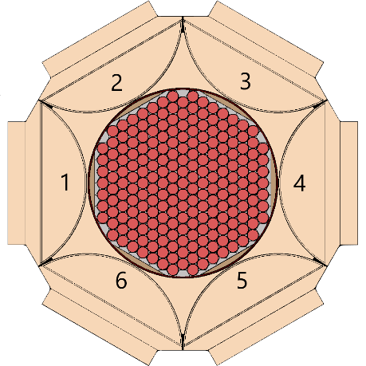

Fig. 4. S8ER core modeled in SERPENT.

Axial portions were then added to the SERPENT model. Fig. 5 below provides an axial cross-section of S8ER calling attention to the length of the shims, support structures for the core, and infrastructure for NaK coolant flow [3].

Fig. 5. S8ER core and reflector section view.

To maximize accuracy, it would be necessary to include components such as the coolant baffle plate, the coolant inlet and outlet, and supporting structures for the reflecting elements. However, their contribution to validating the reactivity is expected to be relatively small, while substantially increasing the complexity of the model. Thus, the process was to first model the inclusion of the upper and lower grid plates, fuel element end caps and axial depth to the shims. The complete analyzed model is shown below in Fig. 6 with some components dimensioned in centimeters.

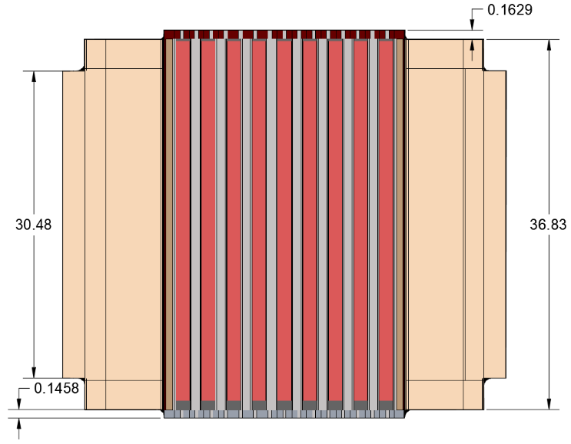

Fig. 6. S8ER core and reflector dimensioned in cm.

The material that is present between the fuel elements seen in Fig. 6 above is air, which is assumed present in the core during the dry critical experiments. This is important because the effect of nitrogen has a small but appreciable effect on reactivity.

**Task 3: Critical Configuration**

With the geometric modeling completed, the final portion falls under modeling the loading schemes at different configurations. Ultimately, the full range of dry experiments will be modelled. Here, a preliminary analysis is performed of four critical experiments, to investigate the validity of the model. The initial loading approach to critical in the experiments was begun with 211 dummy lucite rods with six internal reflectors lining the core wall. Lucite is an acrylic plastic that is transparent to neutron interaction, thus the lucite rods were replaced with loaded fuel-moderator elements as reactivity loading was increased [3]. The loading always began from one side of the core which resulted in crescent-shaped asymmetrical loading patterns. The first configuration, C-1, is explicitly outlined in documentation and shown below in Fig. 7 [3].

Fig. 7. C-1 lucite and fuel loading pattern.

In subsequent iterations the same fuel-moderator element loading method was followed with deviations arising in shim loading and control drum positioning. However, the exact loading arrangement for subsequent configurations, namely C-2 and C-4 were not explicitly shown. It was then decided that the positioning of the lucite pins to model the critical loading scheme should indeed follow the observed asymmetric crescent-shaped loading as seen in Fig. 7. The resulting loading schemes used in SERPENT are shown below in Fig. 8.

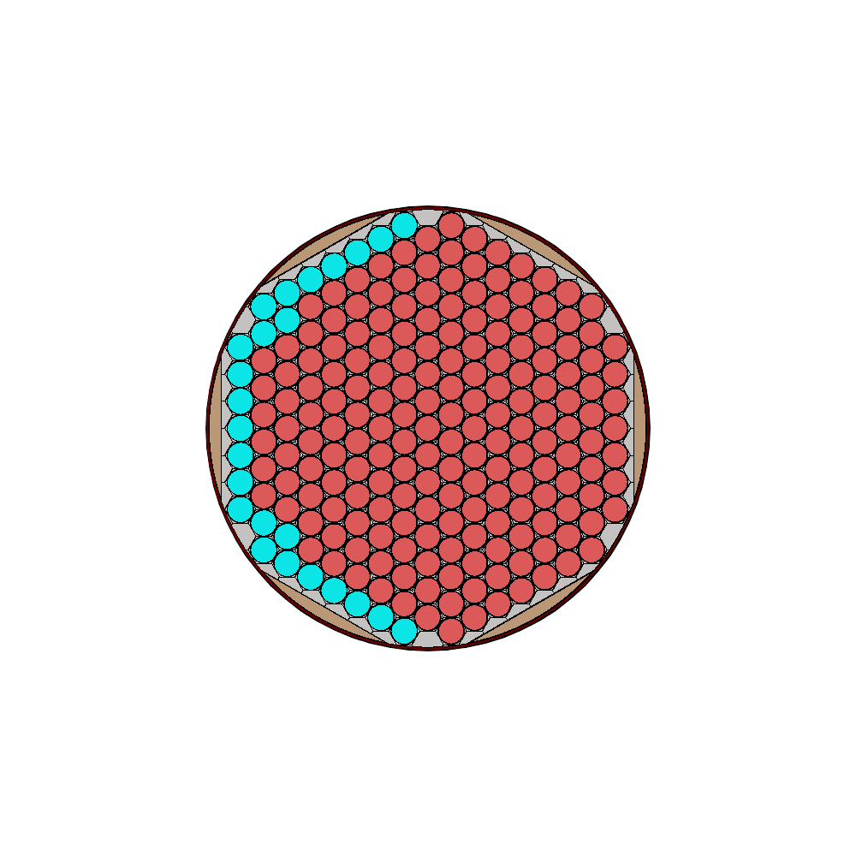

Fig. 8. C-2 (left) and C-4 (right) loading pattern.

RESULTS

The critical loading schemes were run in SERPENT for loading designations C-1 to C-5, where C-5 has the same loading scheme as C-4 with no drums locked out.

TABLE I. S8ER Critical Loading

|  |  |  |  |  |  |
| --- | --- | --- | --- | --- | --- |
|  | Loading Designation | | | | |
|  | C-1 | C-2 | C-3 | C-4 | C-5* |
| Shims installed | A & B | A | None | A & B | A & B |
| Drums locked out | None | None | None | No. 6 | None |
| Number lucite rods | 38 | 25 | 0 | 20 | 20 |
| Measured reactivity [cents] | 9.7 | 14.3 | -28 | 9.3 | 374 |
| Modeled reactivity [cents] | 241.76± 0.026 | 222.30±0.024 | 87.64±  0.0096 | 28.50±  0.0034 | 513.45±  0.049 |
| Measured Reactivity [k] | 1.0007 | 1.0011 | 0.9978 | 1.0007 | 1.0296 |
| Modeled reactivity [k] | 1.0196±0.00010 | 1.0181±0.00011 | 1.0071±0.00011 | 1.0023±0.00012 | 1.0423±0.00010 |

Measured reactivity in terms of k has a reported uncertainty of “less than 1%” [3]. Additionally, the delayed neutron fraction in the measured results was assumed to be 0.0077 and did not have a reported uncertainty. This uncertainty will be determined in future work.

DISCUSSION

The initial results indicate a higher-than-expected reactivity for all cases with C-4 being the closest to experimental results. Given that C-1, C-2, and C-5 are the furthest from experimental results suggest the modelling of the drums may include inaccuracies. This is likely due to the exclusion of the drive shafts that run through the center of the B shim as shown in Fig. 2. Furthermore, apart from the length and thickness of the A and B shim, the exact geometry is not known since there are not any more descriptive dimensioning or sectional views of the shims. Drawings in Ref. [3] would suggest that the A shims are fabricated to be a cutout portion of the drum, i.e., the outside of the shim follows the curvature of the drum. The B shims on the other hand likely have an unknown spacing between the core tie rod and other images would suggest the edges are trimmed at an unspecified angle. At a minimum, future work would look to trim portions of the B shims for the inclusion of the drive shafts.

C-3 is closer to the measured results compared to its aforementioned counterparts, however there is still a sizeable discrepancy. Given that C-3 does not have any shims installed, the source of error likely stems from the modeling of the internal reflectors or drums. Future work will look to other documentation in other SNAP projects for clarification on certain nomenclature and dimensioning. This might better inform the appropriate sizing of the internal reflectors.

Finally, a shared portion of modeling to reconsider when viewing all configurations is the stationary reflectors. When comparing Figs. 2 and 4 the size of the stationary reflectors does not appear consistent. To physically construct and place the stationary reflectors there must be some clearance in between the stationary reflectors, drums, and the core but this is not given in the documentation. The clearance was assumed to be 0.15875 cm (1/16 of an inch); however, this may be larger and would be worth revisiting.

**ACKNOWLEDGEMENTS**

This work was supported by funding received from the DOE Office of Nuclear Energy’s Nuclear Energy University Program under contract number DE-NE0009217. Additionally, the authors would like to thank the support of Dr. Mark DeHart, Dr. Shane Stimpson, and Dr. Bojan Petrovic.

**REFERENCES**

1. S. S. VOSS, “SNAP Reactor Overview”. Kirtland Air Force Base, NM: Air Force Weapons Laboratory, 1984, AFWL-TN-84-14.
2. LEPPᾹNEN, J., et al. (2015) "The Serpent Monte Carlo code: Status, development and applications in 2013." Ann. Nucl. Energy, 82 (2015) 142-150.
3. D.E. CROUTER, “SNAP 8 Experimental Reactor Critical Experiment”. Canoga Park, CA: Atomics International, 1964, NAA-SR-9642.
4. “SNAP 8 Summary Report”. Canoga Park, CA: Atomics International, 1973, AI-AEC-13070